Lab 7 Prelab

**Name**: Chimzim Ogbondah

**Lab Partner Name (if you worked together and are submitting the same document or mostly the same answers):**

**Lab Section**: 1

**Submit your prelab document as a PDF file in Canvas under the corresponding prelab assignment. Every student submits their own prelab. Lab partners are allowed to work on the prelab together and submit the same document (if there is actual collaboration on the document). For full credit, the prelab must be submitted prior to the start of lab. Text responses should be typed or printed neatly.**

Complete the following preparation before doing Prelab 7 and before the Tuesday class meeting: see preparation guide, [reading-prep-TimerIC.pdf](https://canvas.iastate.edu/courses/69323/files/10454624/download?wrap=1), under [Readings – Week 8 - Timers](https://canvas.iastate.edu/courses/69323/pages/readings-week-8-timers). Prep time is estimated as 30-40 minutes.

1. 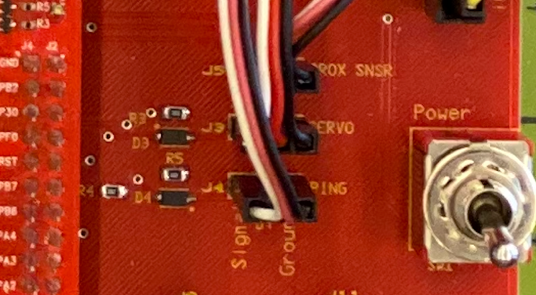System sketch

Similar to system sketches in previous labs, sketch a diagram that shows how the PING))) ultrasonic sensor connects to the microcontroller. Refer to the file Cybot-Baseboard-LCD-Schematic.pdf, as needed. In the photo of the CyBot baseboard, shown at right, the jumper wires are connected to the sensors and servo motor. PING refers to the ultrasonic sensor.

Your diagram should show the port and the pin (or bit) number of the port that the ultrasonic sensor is connected to. Give the port name and pin number used in the microcontroller (e.g, Port A pin 0, PA0).

1. How do you know that the pin the PING))) sensor is connected to (question 1) corresponds to Timer 3B in the microcontroller? Be specific in your explanation.

In table 9.7 timer 3B is connected to T3CCP1 and then if look on table 9.8 T3CCP1 is corresponding with GPIO pin PB3. From the system sketch in question 1 PB-3 lines up with J4-03 which connects to the PING sensor.

1. Write two lines of code to configure the GPIOAFSEL and GPIOPCTL registers to select the Timer 3B (T3CCP1) peripheral signal as an alternate function for the GPIO pin it is connected to.
   1. GPIO_PORTB_AFSEL_R |= 0x8;
   2. GPIO_PORTB_PTCL_R |= 0x8;
2. Refer to the GPTM Timer register list, such as in [GPIO-GPTM-registers-tables.pdf](https://canvas.iastate.edu/courses/69323/files/10454232/download?wrap=1).
   1. Which GPTM register configures the timer so that it detects a particular edge (positive, negative or both) on the CCP input pin?  
      - GPTMCTL
   2. What is the memory address of this memory-mapped I/O register?  
      - 0x4003.300C
   3. Sketch the register as shown in the datasheet description. Circle the bit or bit fields that must be set up for this lab.

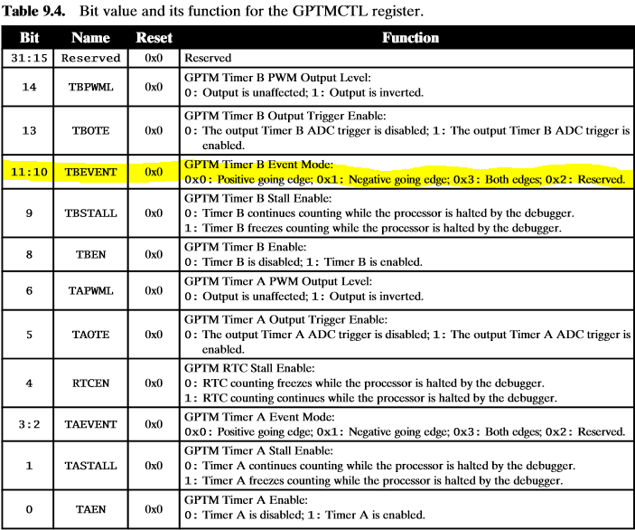

1. The PING))) sensor datasheet specifies the maximum echo pulse width in milliseconds.
   1. What is this value?
      * 18.5ms
   2. Given the speed of sound is 343 meters per second, and the echo pulse width is round-trip distance to the object, what is the maximum distance range of the sensor in meters? Calculate the distance (don’t copy the value from the datasheet).
      * 3.17275
   3. Using a 16 MHz system clock, how many clock periods (or timer steps) are needed for the maximum echo pulse width? State your result in both decimal and hex.

Note: You can watch a short video here, <https://www.parallax.com/product/28015>

1. **Optional** (Bonus): Suppose you don’t have the actual Ping sensor installed yet, but you have been writing some code and want to test your code without the sensor. You wrote test code that uses a wait function from the timer.c library to generate a short high pulse as an output on a GPIO pin (similar to start pulse for Ping). You separately wrote test code that uses a GPTM timer (input edge-time mode) to measure the time of an input pulse on a GPIO pin (similar to echo pulse for Ping). Briefly describe how you could run your test code without a sensor to verify it works. In other words, how might you observe the output pulse generated by your program? How might you create an input pulse for your program to use? (2 points)